(Approx. 280 words)

This and That – Word 2010
By Lynn Page, Newsletter Editor/Webmaster, Crystal River Users Group, FL
December 2012 issue, CRUG newsletter
www.crug.com
lpage46 (at) tampabay.rr.com

Horizontal Lines
AutoCorrect creates a number of different lines according to three characters typed. Type three consecutive hyphens and press enter to create a line. Use underscores to create a bold line or equal signs to create a double line.

☺ Smiley Face
On the Insert tab in the Symbols group select the smiley face icon from the Symbol drop down. ☺ The inserted symbol will have the formatting of the text being used.

Add Captions
To add a caption to an object, select the object and on the References tab in the Captions group click Insert Caption. In the dialog box in the Label drop down select the type of object the caption is being added to. In the position drop down specify where to add the caption. You can change the numbering options and exclude the label from the caption. If you don’t like the options, once added the caption can be changed as any other text.

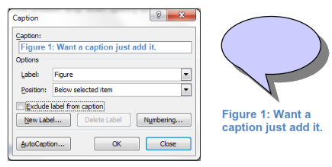

Page Thumbnails
To navigate through a document using thumbnails of pages open the Navigation pane by selecting to show it in the Show group on the View tab. Then on the Navigation pane
select the Browse the pages in your document icon.

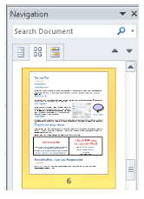

Incognito with Google Chrome
When you don’t want your browsing history to remain on a computer after you leave, use Chrome’s Incognito window. It prevents the PC from retaining most traces of your
browsing. To open a new incognito window in Chrome press Ctrl+Shift+N. Another useful tip is to clear Chrome’s browsing history with Ctrl+Shift+Del.

